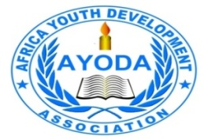

AFRICA YOUTH DEVELOPMENT ASSCIATION
(AYODA)

Report
Safeguarding Training for AYODA staff’s, Volunteers, and interns

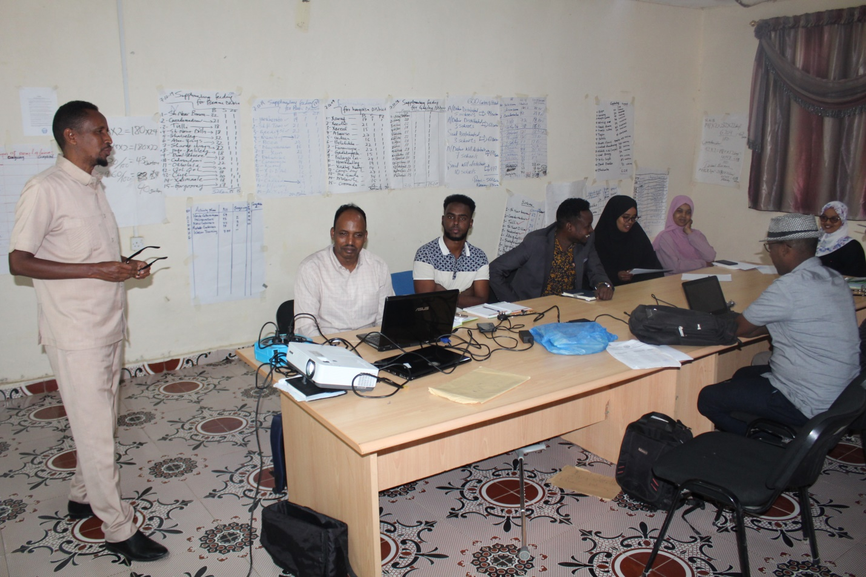

7th to 8th November, 2020
AYODA Meeting Hall, Borama

INTRODUCTION

AYODA organization recently established and developed and adopted Safeguarding policy which AYODA BOD of members approved. Then it became necessary for management to implement this policy therefore management team developed training material and planned to conduct safeguarding policy training about this on 7th to 8th November 2020. Duration on the training was two days
All the staffs that work at the main offices participated the training which took place at AYODA office and participated by 25person from AYODA staffs volunteers and Interns(13 males and 12 female), Training was done hired independent consultant who have an extensive experience
Overall objectives: To train AYODA staffs, volunteers and interns the requirement and lessons on safeguarding policy

Specific objectives
- To make aware AYODA staff about newly developed Safeguarding Policy, and understand key areas of the Policy, know your own responsibility
- Be vigilant in ensuring that we all do everything to make sure that People are safe.
- Be aware of the context, signs and indicators of sexual exploitation and abuse (SEA).Understand why this area of work is such a priority for us
- Ensuring that everyone associated with the organization is aware of and responds appropriately to issues of child abuse and the sexual exploitation of children.
- Ensuring that anyone who represents our organization behaves appropriately towards vulnerable people and never abuses the position of trust that comes with being a member of the AYODA team

Methodology of the training
- Power point presentation
- Interactive Plenary discussion
- Case base discussions
- Information sharing and ideas of exchange
- Participatory approach
- Group work and Group Presentation
- Brainstorming
- Questions

Training sessions 1

First part of the training was about to overview objectives of the training and expectation of the training outcomes that trainer explained during slide presentation where he motivated employee to participate fully for the training sessions and everyone should raise questions related concepts that new to him or her, During this part trainer used talk and jolt method of instruction when he was explained overall objectives of the training. The participant gained knowledge and well understanding about safeguarding terms and definition, also identifying forms of abuse
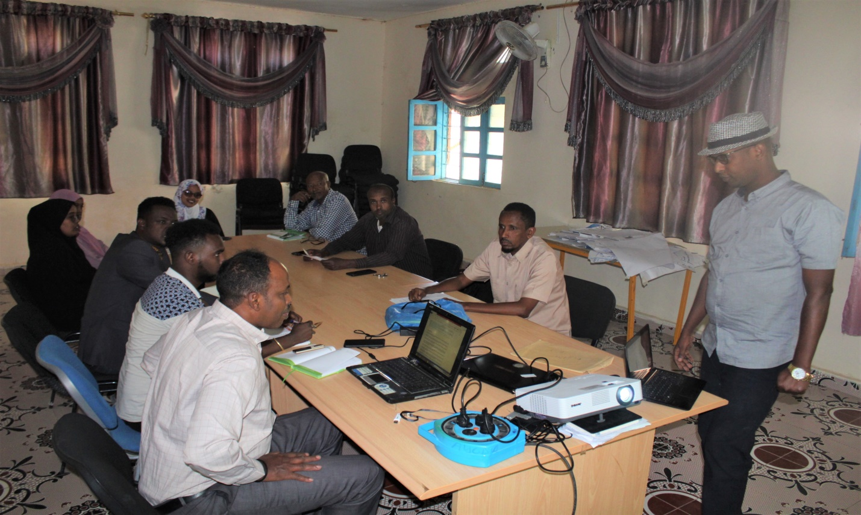

Training Session Two
The sessions of the training participant were briefed safeguarding and protection concepts as well as, trainer had explained factors in local cultures that contribute eliminating of abuse and which promotes abuse cases. The session also projected safeguarding of children and adults and highlighted the differences between child safeguarding and child protection.
During the session trainees were grouped into four groups each consist several employees and facilitator provided questions related child safeguarding and child protection. For example, groups were assigned to discus, brain storm and produce potential answers for the following questions such as what is sexual abuse and Sexual Exploitation abuse safeguarding and harassment, then grouped AYODA staffs discussed these concepts among them, at the end of the session each group presented explanations and answered above stated questions differently. Where other groups and trainer were asking other questions for the group which were presenting at that moment.

Training session Three
After that the trainer continued the training and began the third session which was about the context, signs and indicators of abuse and sexual exploitation and abuse (PSEA and harassment in and outside the organization. During the session he highlighted all possible indicators factors and even environment that attribute future abuse, exploitation and harassment.
The session was interesting according to the participants who raised wonderful examples about the harassment abuse and exploitations it was mentioned how local business employ children long hours without compensations and how young girls and venerable adults exhausting in the benefits of abusers.
During that session trainer also asking oral questions relating cases of abuse, exploitation and harassment which increased participation level and motivating staff to speak freely and assertive ways about these issues
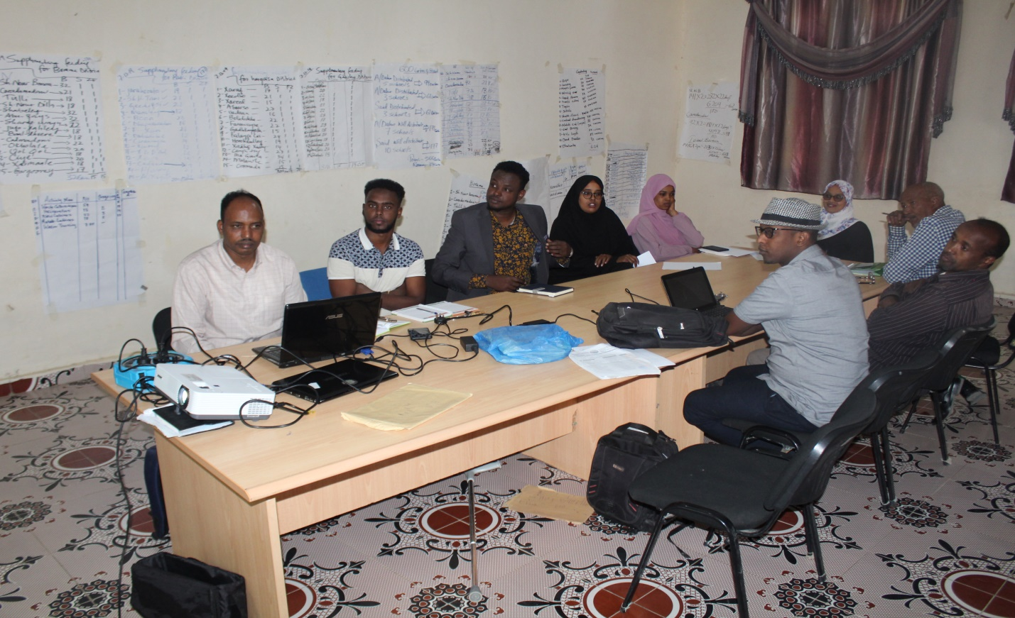
At the end of the session facilitator presented additional AYODA required awareness topic intended for AYODA staffs to understand why this area of work is such a priority for their Organization and communities

Conclusion
Finally employees of AYODA recognized and promised to speak up against these abuse and make others aware about the problems relating these factors in proper way and agreed to sing this policy, that ensuring everyone associated with the organization is aware and willing to respond appropriately to issues of child abuse asexual exploitation of children & adults and being careful harassment cases.
Furthermore after session staffs acknowledged importance and individual responsibility of the AYODA staff as who represents organization behaves appropriately towards vulnerable people and never abuses the position of trust that comes with being a member of the AYODA team.

Annex 1:

AGENDA
DAY 1
8.00- 9.00 | 1 | Welcome & Introduction
9.00- 10.00 | 2.1 | Safeguarding
10.00- 10.30 |  | BREAK
10.30- 11.30 | 2.2 | Child safeguarding
11.30- 12.30 | 3.1 | Protection from sexual, exploitation and abuse (PSEA)
12.30- 1.45 |  | LUNCH
1.45- 3:00 | 3.2 | Plenary Discussion
3:00- 3.15 |  | Wrap up

DAY 2
8.0- 8.15 |  | Recap Day 1
8.15- 9.00 | 3.2 | Child Protection and child safeguarding
9.00- 10.00 | 3.3 | AYODA Safeguarding policy
10.00- 10.30 |  | BREAK
10.30- 11.30 | 4.1 | Plenary Discussion
11.30- 12.30 | 4.2 | Case management process
12.30- 1.45 |  | LUNCH

